**Hello World RESTful Web Service**

**Code –**

*HelloController.java –*

package com.cognizant.spring_learn.controller;

import org.slf4j.Logger;

import org.slf4j.LoggerFactory;

import org.springframework.web.bind.annotation.GetMapping;

import org.springframework.web.bind.annotation.RestController;

*@RestController*

public class HelloController {

private static final Logger ***LOGGER*** = LoggerFactory.*getLogger*(HelloController.class);

*@GetMapping*("/hello")

public String sayHello() {

***LOGGER***.debug("START");

String msg = "Hello World!";

***LOGGER***.debug("END");

return msg;

}

}

*SpringlearnApplication.java –*

package com.cognizant.spring_learn;

import org.springframework.boot.SpringApplication;

import org.springframework.boot.autoconfigure.SpringBootApplication;

@SpringBootApplication

public class SpringLearnApplication {

public static void main(String[] args) {

SpringApplication.run(SpringLearnApplication.class, args);

System.out.println("SpringLearnApplication started...");

}

}

*Application.properties –*

spring.application.name=spring-learn

server.port=8083

*pom.xml –*

<?xml version="1.0" encoding="UTF-8"?>

<project xmlns="http://maven.apache.org/POM/4.0.0" xmlns:xsi="http://www.w3.org/2001/XMLSchema-instance"

xsi:schemaLocation="http://maven.apache.org/POM/4.0.0 https://maven.apache.org/xsd/maven-4.0.0.xsd">

<modelVersion>4.0.0</modelVersion>

<parent>

<groupId>org.springframework.boot</groupId>

<artifactId>spring-boot-starter-parent</artifactId>

<version>3.5.3</version>

<relativePath/> <!-- lookup parent from repository -->

</parent>

<groupId>com.cognizant</groupId>

<artifactId>spring-learn</artifactId>

<version>0.0.1-SNAPSHOT</version>

<name>spring-learn</name>

<description>Demo project for Spring Boot</description>

<url/>

<licenses>

<license/>

</licenses>

<developers>

<developer/>

</developers>

<scm>

<connection/>

<developerConnection/>

<tag/>

<url/>

</scm>

<properties>

<java.version>17</java.version>

</properties>

<dependencies>

<dependency>

<groupId>org.springframework.boot</groupId>

<artifactId>spring-boot-starter-web</artifactId>

</dependency>

<dependency>

<groupId>org.springframework.boot</groupId>

<artifactId>spring-boot-devtools</artifactId>

<scope>runtime</scope>

<optional>true</optional>

</dependency>

<dependency>

<groupId>org.springframework.boot</groupId>

<artifactId>spring-boot-starter-test</artifactId>

<scope>test</scope>

</dependency>

</dependencies>

<build>

<plugins>

<plugin>

<groupId>org.springframework.boot</groupId>

<artifactId>spring-boot-maven-plugin</artifactId>

</plugin>

</plugins>

</build>

</project>

**Output – (Screenshots)**

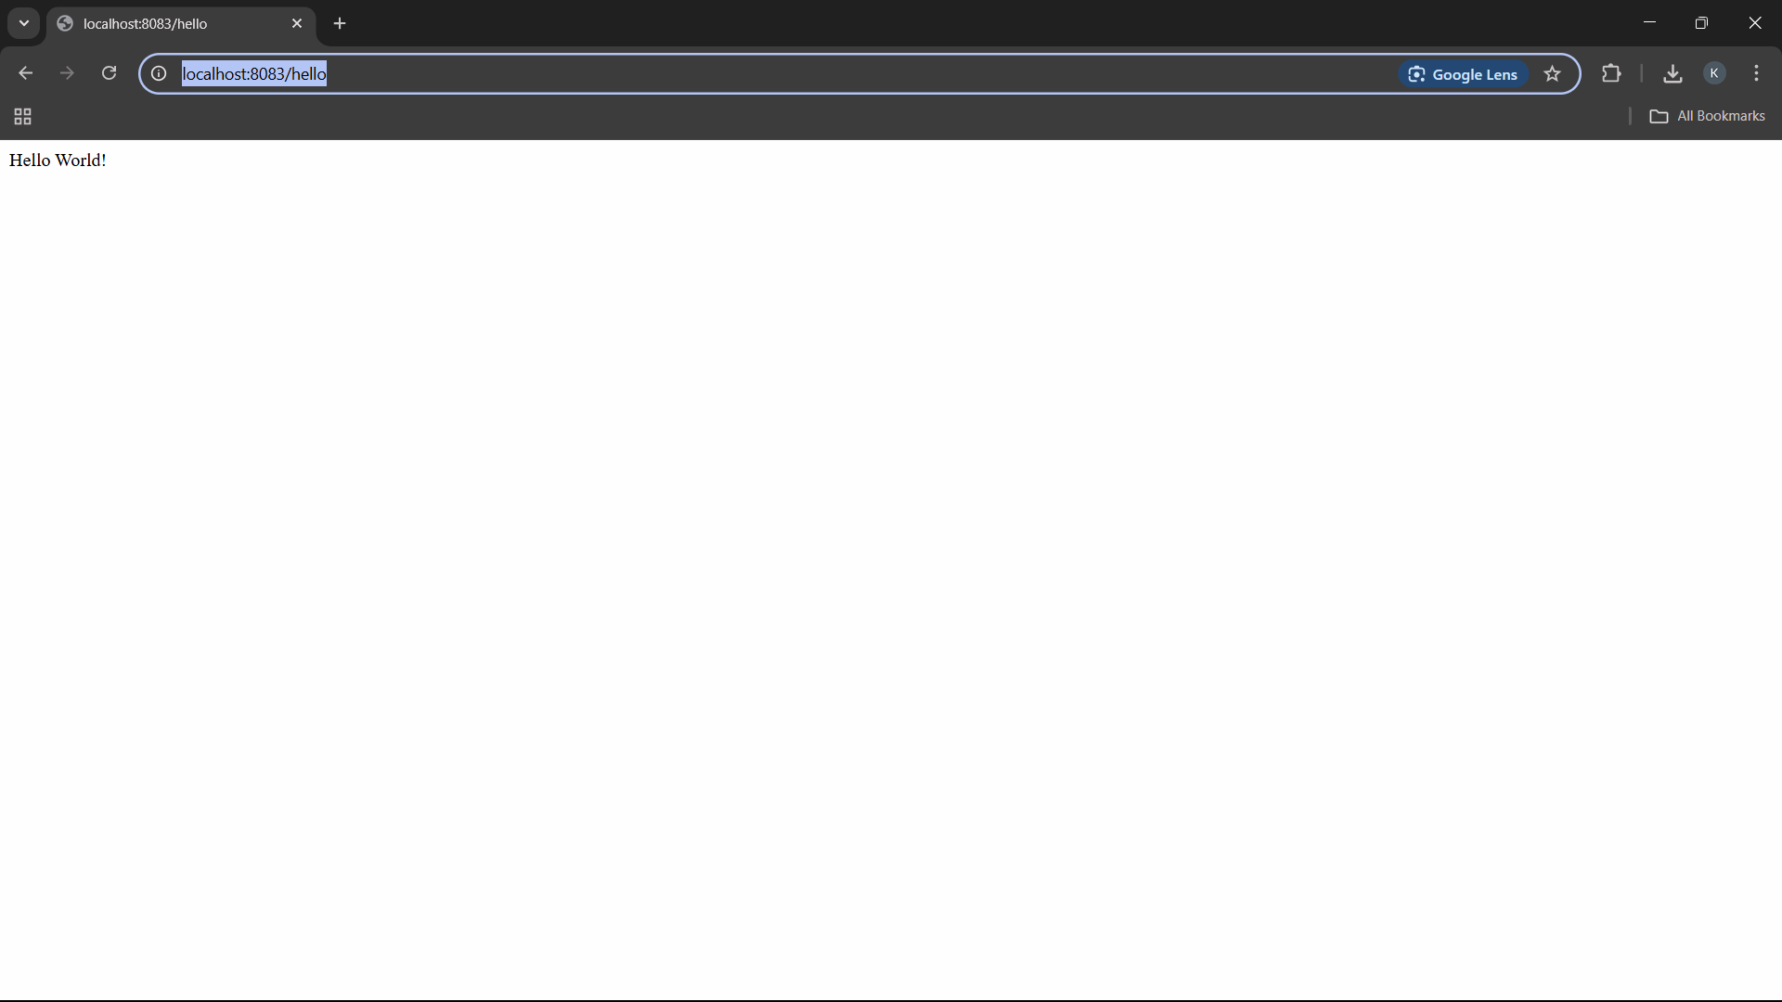

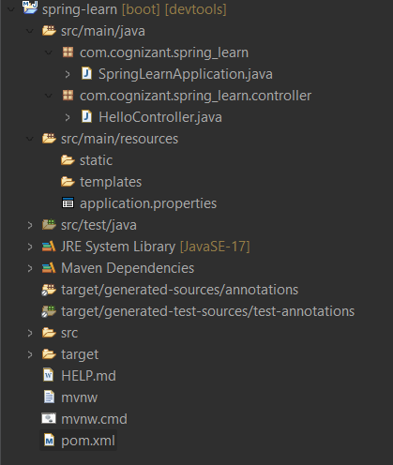

**SME –**

**In network tab of developer tools show the HTTP header details received**

When you open <http://localhost:8083/hello> in Chrome:

1. Open **Dev Tools** → Go to the **Network** tab
2. Refresh the page (F5) → Click on the /hello request

Headers You’ll See (under “Response Headers” and “General”):

HTTP headers give **metadata** about the request and response:

* They tell clients **how to interpret** the response
* Help with **debugging, caching, and security**
* Provide insights on server behavior and content type

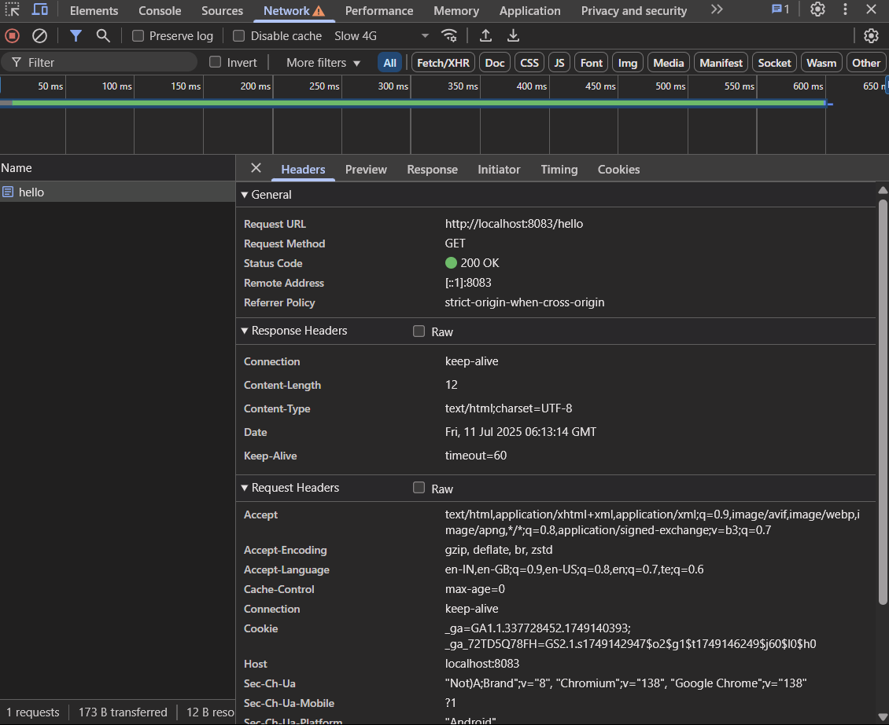

**In postman click on "Headers" tab to view the HTTP header details received**

When you send a GET request to <http://localhost:8083/hello> in **Postman**:

1. Click **"Send"**
2. Go to the **"Headers" tab** under the response section

